**Prime Objective**

The user comes to my site primarily to buy fish, plants, inverts, and hard goods.

**User Stories**

**Dwayne**

I’ll use Dwayne since he just bought 40 shrimp from me yesterday. Dwayne comes to my page and wants to buy 20 blue shrimp. On the page there is a button for shrimp. He presses that button and sees cherry shrimp, blue shrimp, yellow shrimp, and fire red shrimp. Listed under the pictures of the shrimp are prices and an “Add to Cart” button with a quantity section beside it.

Dwayne selects 6 as his quantity and then presses “Add to Cart.” There is a cart logo at the top left of the page and the number 6 is put in the cart. He clicks the cart and it brings him to a Checkout Page. On the checkout page he sees his selection of blue shrimp, the quantity 6 by it, and a subtotal.

Below the subtotal he gets to choose his shipping method. Since he is local he chooses to select “Local Pickup”. He clicks on that and a small calendar pops up where he can select a day and time. Some days and times are blacked out. He’s available tomorrow and 5pm and that is able to be selected, so he chooses that.

The calendar goes away and “Arrange Pickup” is followed by the selected date and time now.

Dwayne sees his subtotal of $4 x 6 = $24. He sees that pickup is free so his total which he reads from the total line is $24.00.

Dwayne then chooses to pay through PayPal by clicking the PayPal button.

He is then brought to the PayPal website where he sees and invoice for $24.00. He pays that and then is directed back to the site where he reads, “Your order is complete. An email has been sent to you with a receipt for this transaction.”

He checks his email and sees he has an email from PayPal with the payment confirmation and an email from my site. He checks the email from my site and it has his order and his pickup time and date.

He comes the next day and picks up his shrimp.

**Sue**

Sue wants to buy some aquatic plants for her tank. On the page there is a button for plants. She presses that button and sees Water Sprite, Ludwigia Repens, Guppy Grass, Micro-sword, and Duckweed. Listed under the pictures of the plants are prices with a “sandwich size bag” label by the price, and an “Add to Cart” button with a quantity section beside it.

Sue selects 2 as her quantity and then presses “Add to Cart” for Guppy Grass, Ludwigia Repens, and Water Sprite. There is a cart logo at the top left of the page and the number 6 is put in the cart. She clicks the cart and it brings her to a Checkout Page. On the checkout page she sees her selection of plants, the quantity 2 by each, with a total quantity and a subtotal after the plants.

Below the subtotal she gets to choose her shipping method. She chooses for it to be shipped and a window opens up for her to put in her mailing address. She does that and then when selecting enter for her mailing address, it beings her back to the checkout page with $20 added to her total for shipping.

Sue sees her subtotal of $5 x 6 = $30. She then sees that shipping is $20 so her total which she reads from the total line is $50.00.

Sue then chooses to pay using her card so she begins to enter her card information in the billing section.

After putting in her billing information and inspecting the page, she clicks on the “Confirm Purchase” button and is then brought to a site that reads, “Your order is complete. An email has been sent to you with a receipt for this transaction.”

She checks her email and sees she has an email from my site. She checks the email from my site and it has her order and instructions that a confirmation number will be sent to her when the items are shipped and to expect that in 3-5 business days.

Her plants arrive the next week.

**Shay**

Shay knows me and wants to buy some guppies. She messages me and I tell her hop on the site and order the guppies she wants, then select “pickup” and select “cash on arrival” on the site. I’ll have them ready tomorrow for her. So she hops on the site and on the page there is a button for fish. She presses that button and sees pictures and labels with Guppies, Neon Tetras, Rainbows, Odessa Barbs, Jewel Cichlids, Bristle-nose Plecos, Albino Bristle-nose Plecos, and Super Red Bristle-nose Plecos. Listed under the pictures of the fish are prices and an “Add to Cart” button with a quantity section beside it.

Shay selects 50 as her quantity for guppies and then presses “Add to Cart”. There is a cart logo at the top left of the page and the number 50 is put in the cart. She clicks the cart and it brings her to a Checkout Page. On the checkout page she sees her selection of fish, with a total quantity and a subtotal after the fish.

Below the subtotal she gets to choose her shipping method. She chooses “Local Pickup”. She clicks on that and a small calendar pops up where she can select a day and time. Some days and times are blacked out. She chooses one at random because I told her it doesn’t matter what she picks since she already arranged it with me.

The calendar goes away and “Arrange Pickup” is followed by the selected date and time now.

Sue sees her subtotal of $1 x 50 = $50. She sees that pickup is free so her total which she reads from the total line is $50.00.

Sue then chooses the “Pay during Pickup” method.

After inspecting the page, she clicks on the “Confirm Purchase” button and is then brought to a site that reads, “Your order is complete. An email has been sent to you with a receipt for this transaction.”

She checks her email and sees she has an email from my site. She checks the email from my site and it has her order and the selected day and time for pickup.

She comes at her predetermined time and I give her 50 guppies because I have a bunch and I don’t want to charge her.

**Site Map**

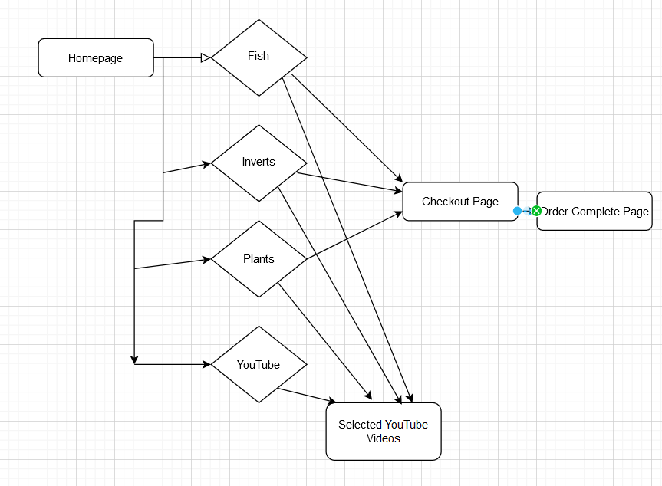

**Low Fidelity Wire Frames**

